ERASMUS+ PROJECT
2019/2022
Student profile questions

Photo:

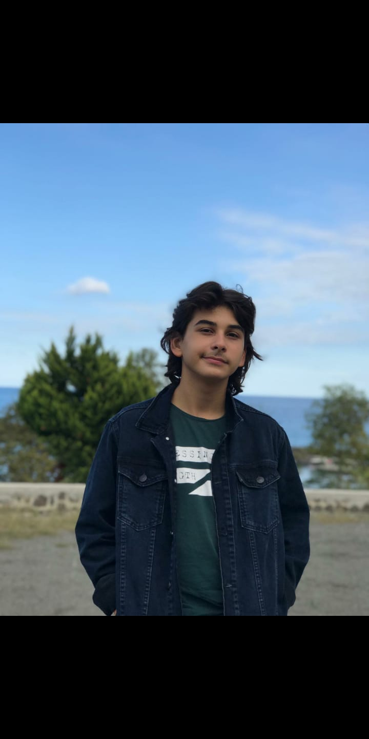

Name: Arda Köz
Year of birth: 29/08/2005

What are your hobbies?
I like to watch series online, listen to podcasts, read books and my favorite hobby to do is playing video games.
What is your favourite music or singer?
It’s probably Mick Gordon. I really enjoy his music and OSTs.
What kind of movie do you like?
I like science fiction movies than the other movie genres.
What kind of book do you like?
I really like psychological fiction because for me the human mind is an infinite place to discover.
Name three (3) of your favorite food?
My favorite food by far is a Turkish food named iskender and for the other two foods I’ll say hotdogs and pizza.
Which animal would you like to be?
If I want to be an animal I’ll probably choose to be an eagle.
What three (3) things would you take to a desert island?
Food supply, water and my closest friend.
Choose three (3) adjectives that define you.
Outgoing, friendly, reliable
Contacts:
Instagram: kozarda4
Facebook ------
Others: Discord: KoZar#5938

